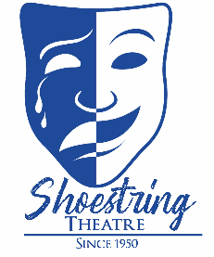
CORPORATE SPONSORSHIP OPPORTUNITES
Shoestring Theatre  380 S. Goodwin St.  Lake Helen, Florida  32744
Mail check (payable to Shoestring Theatre) and completed form to:
Company Name: __________________________________________________________________
Contact Name: ___________________________________________________________________
Address: ___________________________________________________________________
City: ____________________ State: _____________________ Zip: ________________________
Phone (Business): ____________________________ (cell) ________________________________
Email: _____________________________________ Website: _____________________________
Shoestring Theatre is a 501(c)(3) non-profit organization. As a corporate sponsor your organization will gain level benefits. Your generous contribution will help to ensure Shoestring Theatre will continue to provide wonderful theatrical
productions for our community. Sponsorship letter will denote sponsorship less the cost of tickets received.

Standing Ovation | $800 | - Season Sponsorship Pass for two people to ALL shows.  - Company name included on all show posters displayed throughout the community for the season.  - Full page advertisement in all regular season programs and on lobby display for the season.  - Recognition on website with direct link to your company’s website.  - Featured Social Media recognition.
Break A Leg | $500 | - Company name included on all show posters displayed throughout the community for the season.  - Recognition on website— no direct link included.  - Full page advertisement in all regular season programs for the season.  - 2 mini season tickets to the performances of your choosing.
Green Room | $350 | - Half-page advertisement in all regular season programs for the season.  - 4 regular season tickets to the performance/s of your choosing.
Ghost Light | $250 | - Quarter page advertisement in all regular season programs for the season.  - Three tickets (to be used one time) at the performance of your choosing.
Stagehand | $100 | - Business Card size advertisement in all regular season programs.  - Two tickets (to be used one time) at the performance/s of your choosing.
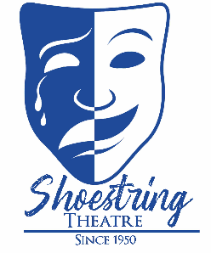
CREATIVE ARTS CENTER
CORPORATE SPONSORSHIP OPPORTUNITES

Shoestring Theatre is a 501(c)(3) non-profit organization. As a corporate sponsor your organization will gain level benefits. Your generous contribution will help to ensure Shoestring Theatre will continue to provide access and exposure to the arts for our community. Sponsorship letter will denote sponsorship less the cost of tickets received.

Company Name: __________________________________________________________________
Contact Name: ___________________________________________________________________
Address: ___________________________________________________________________
City: ____________________ State: _____________________ Zip: ________________________
Phone (Business): ____________________________ (cell) ________________________________
Email: _____________________________________ Website: _____________________________
CAC Spotlight | $2,500 | - Design input for apartment façade in theatre room displayed for one calendar year  - Admission for 2 to each Creative Arts Center Benefit Night event (Season Opening, New Year’s and Valentine’s)  - Company logo in all production programs at Shoestring Mainstage and Creative Arts Center benefit night advertisements at Creative Arts Center for the season  - Sponsor Recognition plaque
Art Table | $1,000 | - Theatre room tables displayed with works from Volusia County student artists with company logo displayed in center as Tables Sponsor.  - Company name included on Creative Arts Center programming advertisements and announcements displayed throughout the community for the season.  - Admission for 2 to the Annual Creative Arts Center Season Opening Benefit Night.
Creative Arts | $500 | - Company logo displayed on Creative Arts Center’s “Artist’s Corner” Wall.  - Company name included on Creative Arts Center programming advertisements and announcements displayed throughout the community for the season.
Mail check (payable to Shoestring Theatre) and completed form to:
Shoestring Theatre  380 S. Goodwin St.  Lake Helen, Florida  32744
Mail check (payable to Shoestring Theatre) and completed form to:
Shoestring Theatre  380 S. Goodwin St.  Lake Helen, Florida  32744

